📘 **CONTENT MARKETING STRATEGY FOR PEANUT BUTTER BRAND**

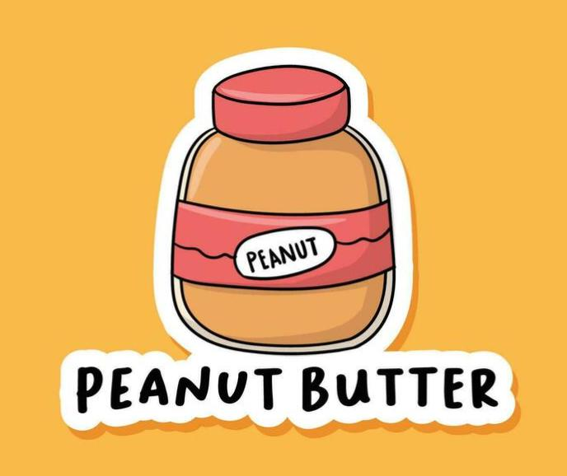

1. **Brand Overview**

Our brand focuses on delivering high-quality, all-natural peanut butter made from roasted peanuts with no added preservatives. Positioned as a health-focused, tasty spread, our product appeals to both fitness enthusiasts and everyday consumers looking for nutritious options.

2. **Objectives**

* Increase brand awareness in the health and wellness market
* Drive website traffic and online sales
* Build brand authority in the healthy food niche
* Engage and educate the audience through informative content
* **3. Target Audience**

**Segment Description**

* **Fitness Enthusiasts** --Gym-goers, athletes, and bodybuilders looking for high-protein food.
* **Health-Conscious Individuals** --Consumers preferring low-sugar, preservative-free products.
* **Parents --**Moms and dads seeking healthy breakfast or snack options for kids.
* **Vegans & Vegetarians** --Peanut butter as a protein-rich meat alternative.
* **Millennials/Gen Z**--Social media users drawn to trends in healthy eating and DIY recipes.

**4. Content Pillars & Blog Topics**

🟠 **Health & Nutrition**

“10 Health Benefits of Eating Peanut Butter Daily”

“Peanut Butter vs Almond Butter: Which is Better?”

“Is Peanut Butter Good for Weight Loss or Muscle Gain?”

🟢 **Recipes & DIY Ideas**

“5 Quick Peanut Butter Breakfast Recipes”

“DIY Energy Balls with Peanut Butter”

“Peanut Butter Smoothies for a Post-Workout Boost”

🔵 **Lifestyle & Inspiration**

“What a Day of Eating Looks Like with Peanut Butter in Every Meal”

“Healthy Meal Prep Using Peanut Butter”

“Why Fitness Influencers Love Peanut Butter”

🟣 **Behind the Brand**

“Our Story: How We Make Peanut Butter with Purpose”

“A Day in the Life at Our Peanut Butter Factory”

“Why We Never Add Sugar to Our Peanut Butter”

**5. Content Formats**

* Blog articles (SEO optimized)
* Instagram Reels & Stories
* YouTube recipe videos
* Pinterest recipe pins
* Infographics on health benefits
* Podcasts with nutritionists
* Email newsletters

**6. Promotion Channels**

🌐 **Owned Media**

* Website blog
* Email marketing
* YouTube channel

📱 **Social Media**

* Instagram (reels, influencer partnerships)
* Facebook (recipe shares, community groups)
* Pinterest (recipe pins)
* Twitter (tips, health facts)

**📢 Earned & Paid Media**

* Influencer collaborations
* Sponsored posts on fitness blogs
* Facebook & Instagram ads targeting health-conscious users
* PR in food and health magazines

**7. Content Calendar (Example for 1 Month)**

|  |  |  |  |  |
| --- | --- | --- | --- | --- |
| **Week** | **Blog post** | **Instgram content** | **You tube** | **Newsletter** |
| Week 1 | 10 Benefits of Peanut Butter | Fitness tip reel | Peanut Butter Smoothie | Welcome + Discount |
| Week 2 | Weight Loss with PB | Recipe Carousel | DIY Energy Balls | Top 3 Recipes |
| Week 3 | PB vs Almond | Behind the scenes story | Meet the Makers | FAQs |
| Week 4 | Vegan Meal Prep Ideas | Influencer Collab | Full Day PB Diet | Loyalty Program |

**8. Measurement & KPIs**

|  |
| --- |
| **Metric** **Goal**  Website Visitors +30% in 3 months  Blog Traffic 10K visits/month  Social Engagement. 5K interactions/month  Newsletter Signups. 1K new/month  Sales Conversion. 3% from content |

**9. Tools & Platforms**

**CMS**: WordPress

**Email Marketing**: Mailchimp

**Design**: Canva, Adobe Express

**SEO**: SEMrush, Yoast SEO

**Analytics**: Google Analytics, Instagram Insights

**10. Conclusion**

This content marketing strategy positions our peanut butter as not just a product, but a lifestyle companion. Through informative, engaging, and SEO-optimized content distributed via the right channels, we aim to build brand loyalty, expand reach, and increase sales while creating a positive health-conscious brand image.